Eclipse



The Eclipse feature is located on the right side of the Toolbar.  It links to a list of all updates and changes made to the HBS settings. The number to the right displays the number of updates since you last opened the application, which will disappear after you next view the update list (until another update occurs, at which point it will start over at “1”).

Click on “Eclipse” to view the update list:

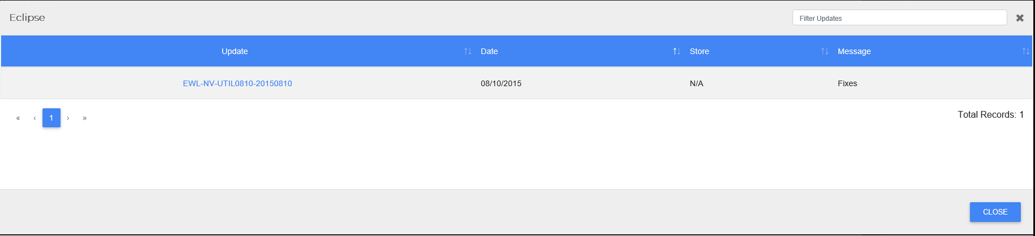

Each entry shows the update name, the update date, what store location the update was connected with, and a description of what was changed.   The updates are listed from newest update to oldest, but you can use the sortable column headers (except for the Message column) to reorder the list. You can also use the **Filter Updates** column to locate a specific update by entering data that would appear in the update’s entry.

**Viewing Update Details:** If the update name is blue, then there is an update document attached to the entry. Click on the name to view the update document (example shown below):

